**Microsoft Teams**

# Overview

* Chat-based and collaborative workspace; not a content/document management system
* Threaded conversation - messages are kept together with the original post
* Brings together all the other Office 365 components. Every team in MS Teams has an Office 365 group – shared SharePoint site, shared Mailbox, and OneNote notebook.
* Each team has one owner (by default); can have a maximum of 10 owners and 999 members
* Meetings – schedule and join meetings on other platforms
* Share Files – with your team, simultaneous editing, files get stored in SharePoint/OneDrive
* Wiki – wiki tab, editing tools, initiate reviews, make changes in a controlled manner
* Search – for groups/people/information/file content

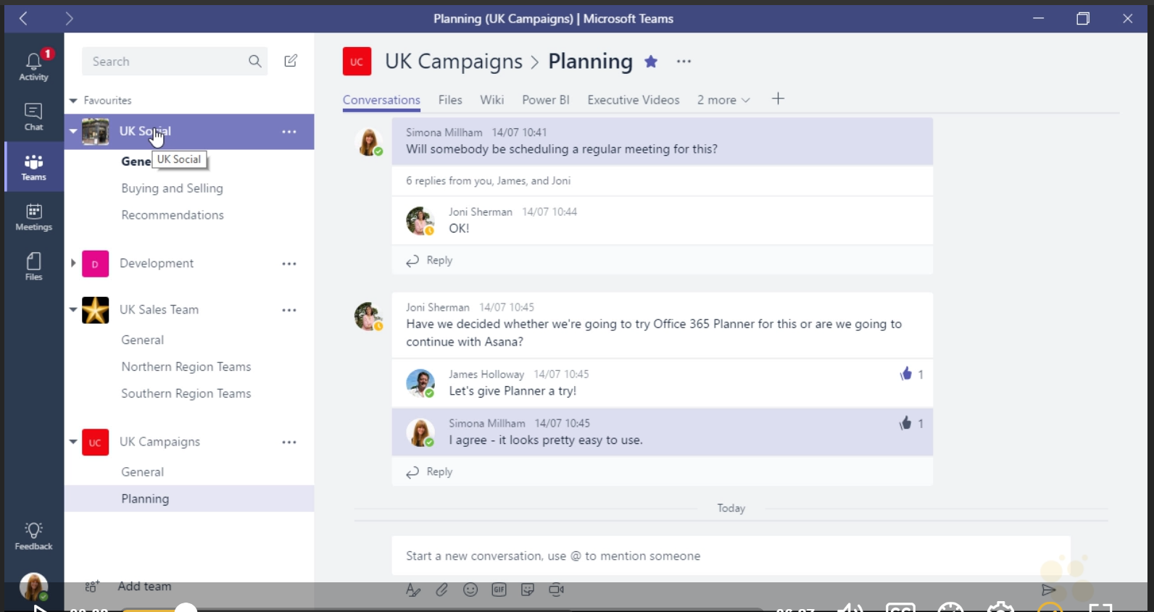

# Comparison with Skype

| Feature | Skype for Business | Microsoft Teams |
| --- | --- | --- |
| Instant messaging |  |  |
| Presence |  |  |
| Threaded chat |  |  |
| Voice calls |  |  |
| Video calls |  |  |
| Group meetings |  |  |
| Scheduled meetings |  |  |
| Join meeting on other platforms |  |  |
| One click search |  |  |
| Inter-platform chat |  |  |
| Mobile platform |  |  |
| Access to SharePoint/files |  |  |
| Indexes file content |  |  |
| Displays meeting from Outlook calendar |  |  |
| Access to OneNote |  |  |
| Office 365 Group Connectors |  |  |
| Cost | Part of Office 365 package, so no additional cost | |

**GitHub**

# Overview

* Web-based version control repository hosting service
* Create documentation website, wiki, knowledge base
* Ideal for source codes
* Viewable by all regions
* Cost - $ 9 per person per month
* SSO is only available with the Business Plan ($25 per person/per month)
* No single source output – only HTML
* Supports version control and workflow
* Does not support Word; only supports .md format – markdown
* In addition to storing the source code, it supports the following features:
  + Documentation
  + Issue tracking
  + Wikis
  + Commit history
  + Email notifications
  + @mentioning for reviews
  + PDF document viewer